Assignment No -4
1. Employee and Address
Problem Statement:
Create an Employee class that contains an object of an Address class representing the employee's residential address. The Address class should contain area,city, and PIN code. Accept and display the complete employee and address details.implement constructors.

Concept: Object of one class as a data member of another class.
#include <iostream>
#include <string>

using namespace std;

// Address class to store location details
class Address {
private:
string area;
string city;
string pinCode;

public:

Address(string a, string c, string p) {
area = a;
city = c;
pinCode = p;
}

void displayAddress() const {
cout << "Area: " << area << endl;
cout << "City: " << city << endl;
cout << "PIN Code: " << pinCode << endl;
}
};

class Employee {
private:
string name;
int id;
Address address;

public:

Employee(string empName, int empId, Address empAddress)
: name(empName), id(empId), address(empAddress) {}

void displayEmployeeDetails() const {
cout << "\n--- Employee Details ---" << endl;
cout << "ID: " << id << endl;
cout << "Name: " << name << endl;
cout << "--- Residential Address ---" << endl;
address.displayAddress();
}
};

int main() {
int id;
string name, area, city, pinCode;

cout << "Enter Employee ID: ";
cin >> id;
cin.ignore();

cout << "Enter Employee Name: ";
getline(cin, name);

cout << "Enter Area: ";
getline(cin, area);

cout << "Enter City: ";
getline(cin, city);

cout << "Enter PIN Code: ";
getline(cin, pinCode);

Address empAddress(area, city, pinCode);

Employee emp(name, id, empAddress);

emp.displayEmployeeDetails();

return 0;
}

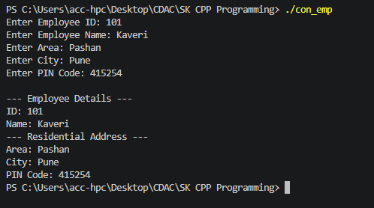

2.Employee and Joining Date
Problem Statement:
Create an Employee class that contains an object of a Date class representing the employee's joining date. The Date class should contain day, month, and year. Accept employee ID, employee name, salary, and joining date, and display all the details.
Concept: Employee has-a Date.
#include <iostream>
#include <string>

using namespace std;

class Date {
private:
int day;
int month;
int year;

public:

Date() : day(1), month(1), year(2000) {}

Date(int d, int m, int y) : day(d), month(m), year(y) {}

// Function to accept date details from the user
void acceptDate() {
cout << "Enter Day (DD): ";
cin >> day;
cout << "Enter Month (MM): ";
cin >> month;
cout << "Enter Year (YYYY): ";
cin >> year;
}

void displayDate() const {
cout << day << "/" << month << "/" << year;
}
};

class Employee {
private:
int empId;
string name;
double salary;
Date joiningDate; // Composition

public:

void acceptEmployeeDetails() {
cout << "Enter Employee ID: ";
cin >> empId;
cin.ignore();

cout << "Enter Employee Name: ";
getline(cin, name);

cout << "Enter Salary: ";
cin >> salary;

cout << "--- Enter Joining Date ---" << endl;
joiningDate.acceptDate();
}

void displayEmployeeDetails() const {
cout << "\n===================================" << endl;
cout << " EMPLOYEE DETAILS " << endl;
cout << "===================================" << endl;
cout << "Employee ID : " << empId << endl;
cout << "Name : " << name << endl;
cout << "Salary : $" << salary << endl;
cout << "Joining Date : ";
joiningDate.displayDate();
cout << endl << "===================================" << endl;
}
};

int main() {
Employee emp;

cout << "Enter details for the employee:" << endl;
emp.acceptEmployeeDetails();

emp.displayEmployeeDetails();

return 0;
}

